Common Ground High School District our membership in the DemandStar network. DemandStar is an online marketplace that connects our suppliers directly to the bids, quotes, and RFP’s that matter to them.
DemandStar is open and accessible to all businesses and provides instant access to our solicitations. By registering for your complimentary DemandStar account you will receive.
- Instant access to all bid and quotes for Common Ground High School District, CT
- Automatic notifications, right to your inbox of the solicitations that match the commodity codes you select
- The ability to quickly view the contractual terms and scope of work
- All the forms and documents you need in one place.
- Access to more government bids in neighboring cities, counties and states
It’s EASY! Get started with 3 easy steps!

 | REGISTER  Go to demandstar.com/registration | 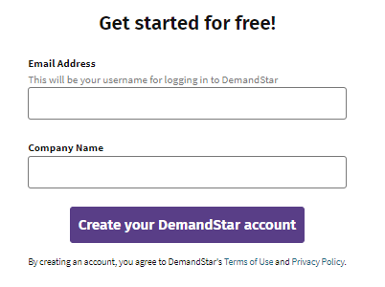
 | & CHOOSE YOUR FREE AGENCY  Type “Common Ground High School District” in the Search Box and check the bubble next to the name, then hit Next | 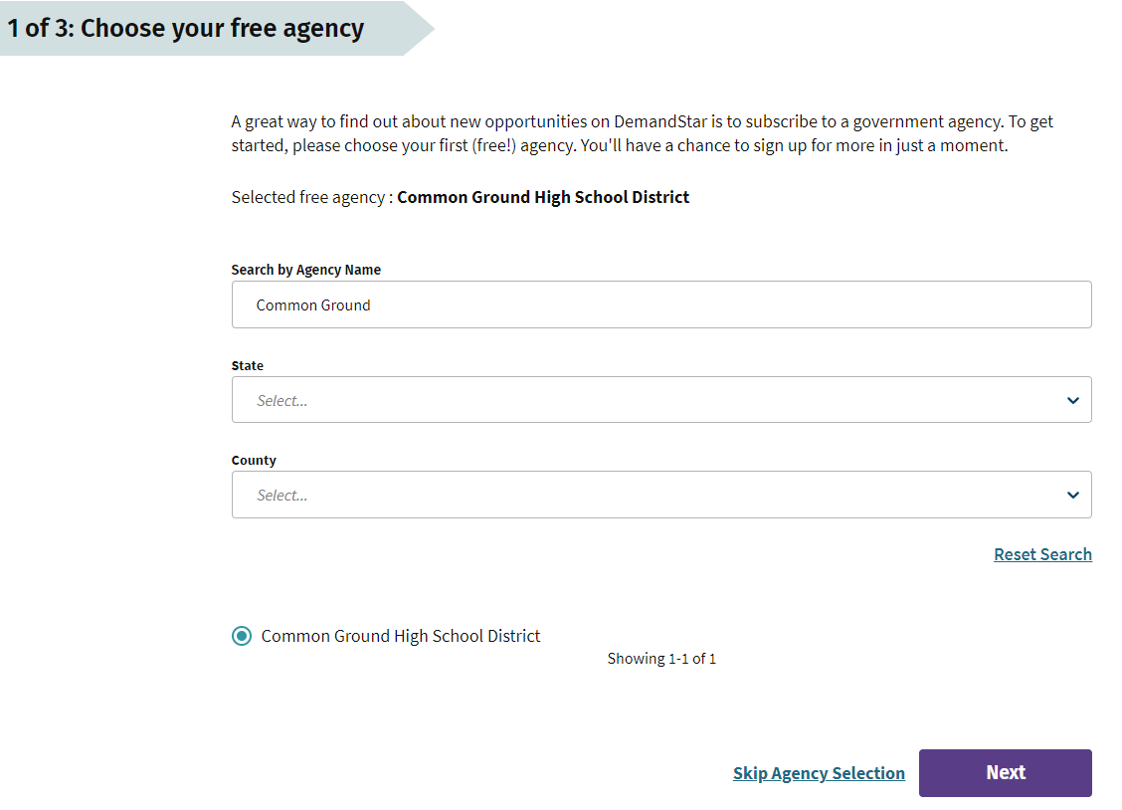
 | CHOOSE MORE NOTIFICATIONS  Click “Next” to proceed with a free account to receive notifications solely for Common Ground High School District. Or, if you’d like to get notifications when other governments near you post a relevant solicitation, you can select any combination of our county, state, or national plans on this page. | 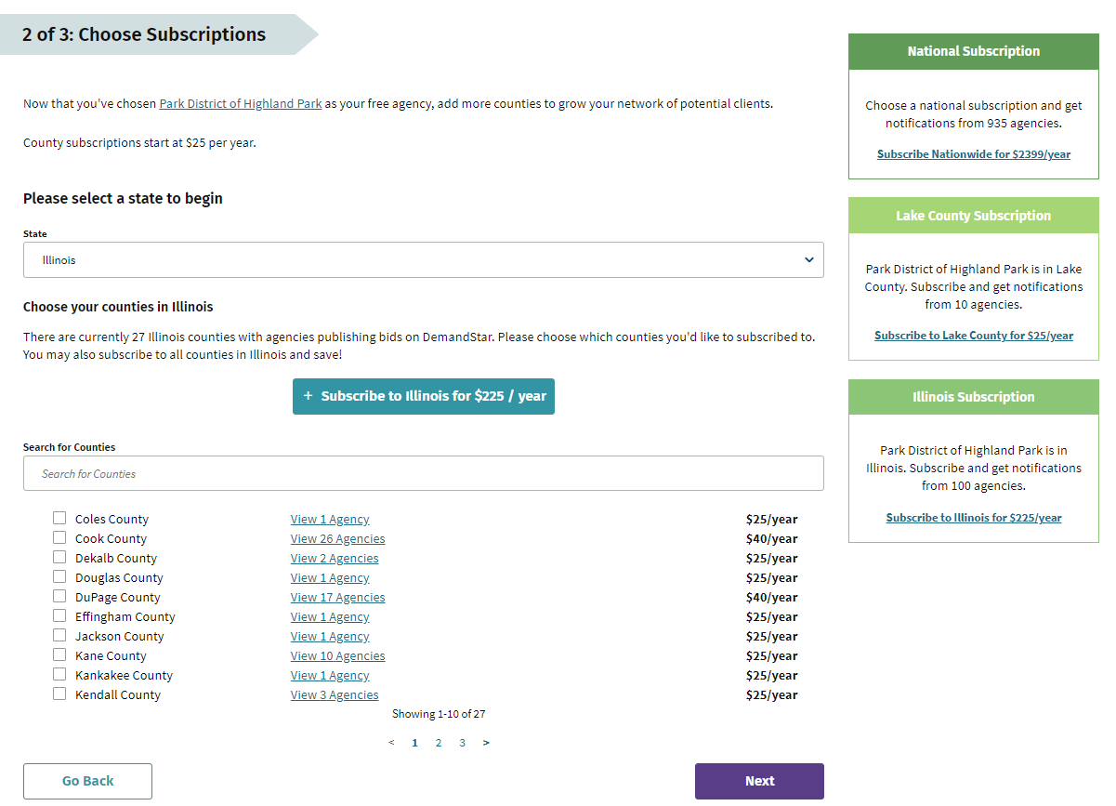
 | COMPLETE YOUR PROFILE –  Enter your contact and company information and you’re done! | 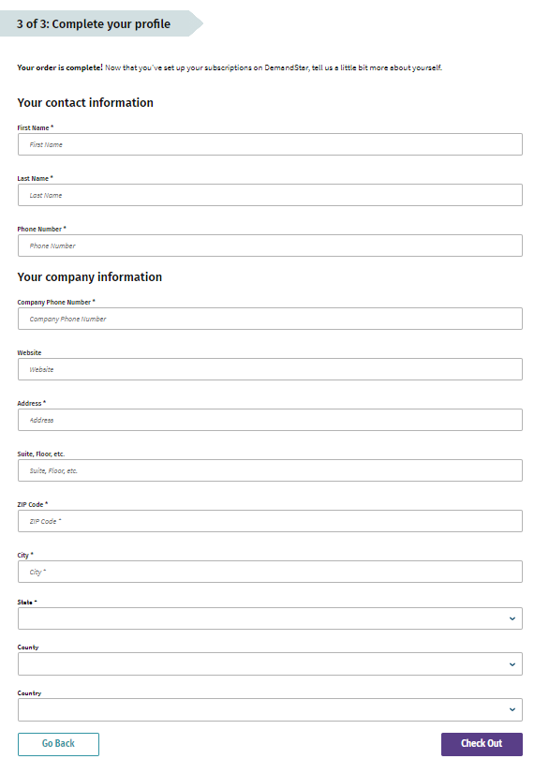

Visit www.demandstar.com

